**Staff**

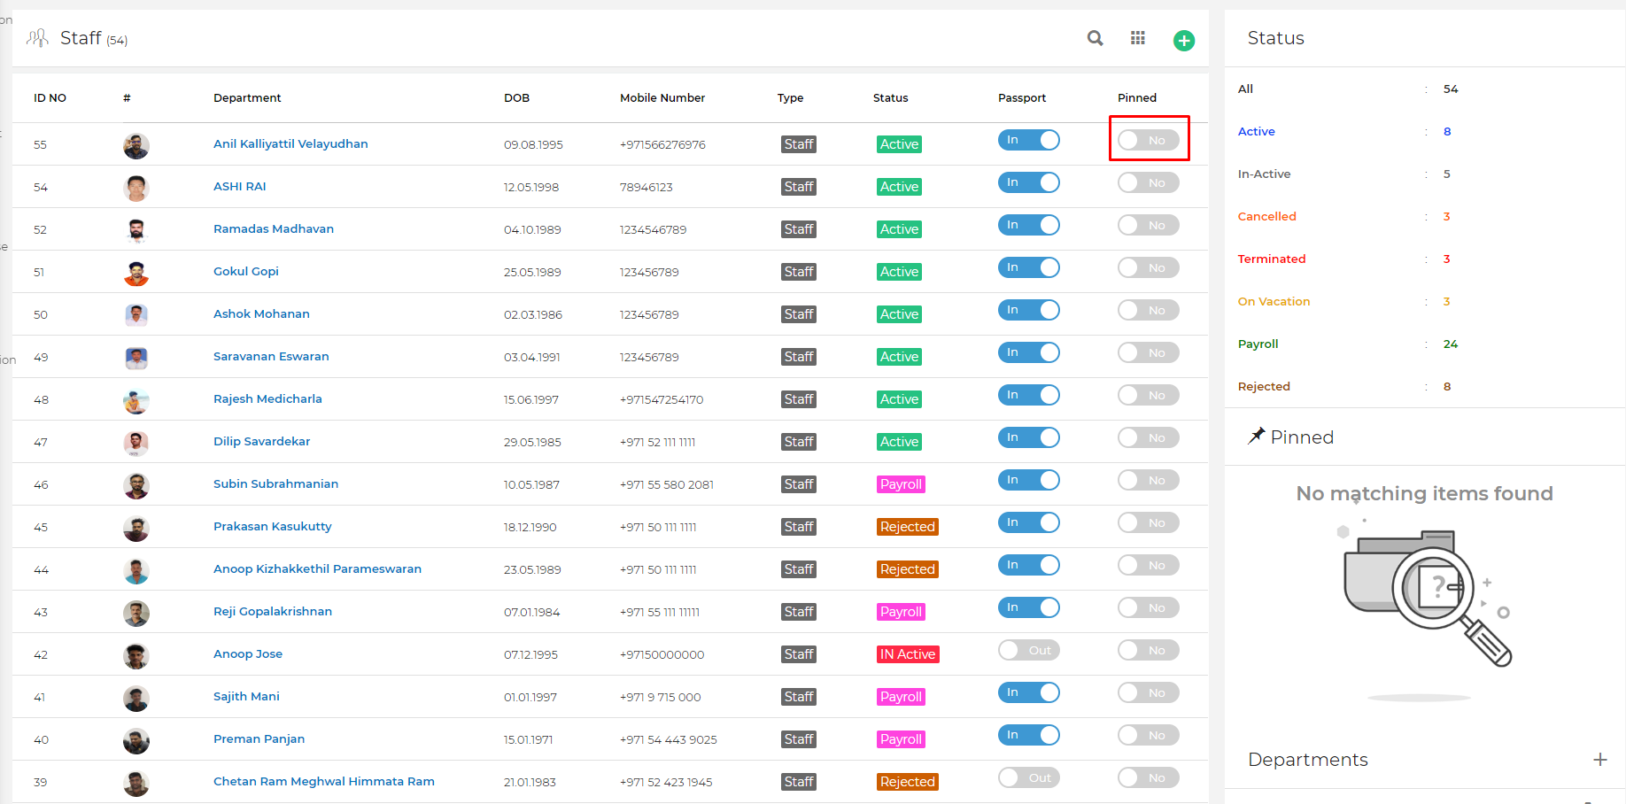

**Change the pinned icon I need it like this which is existed in the projects]**

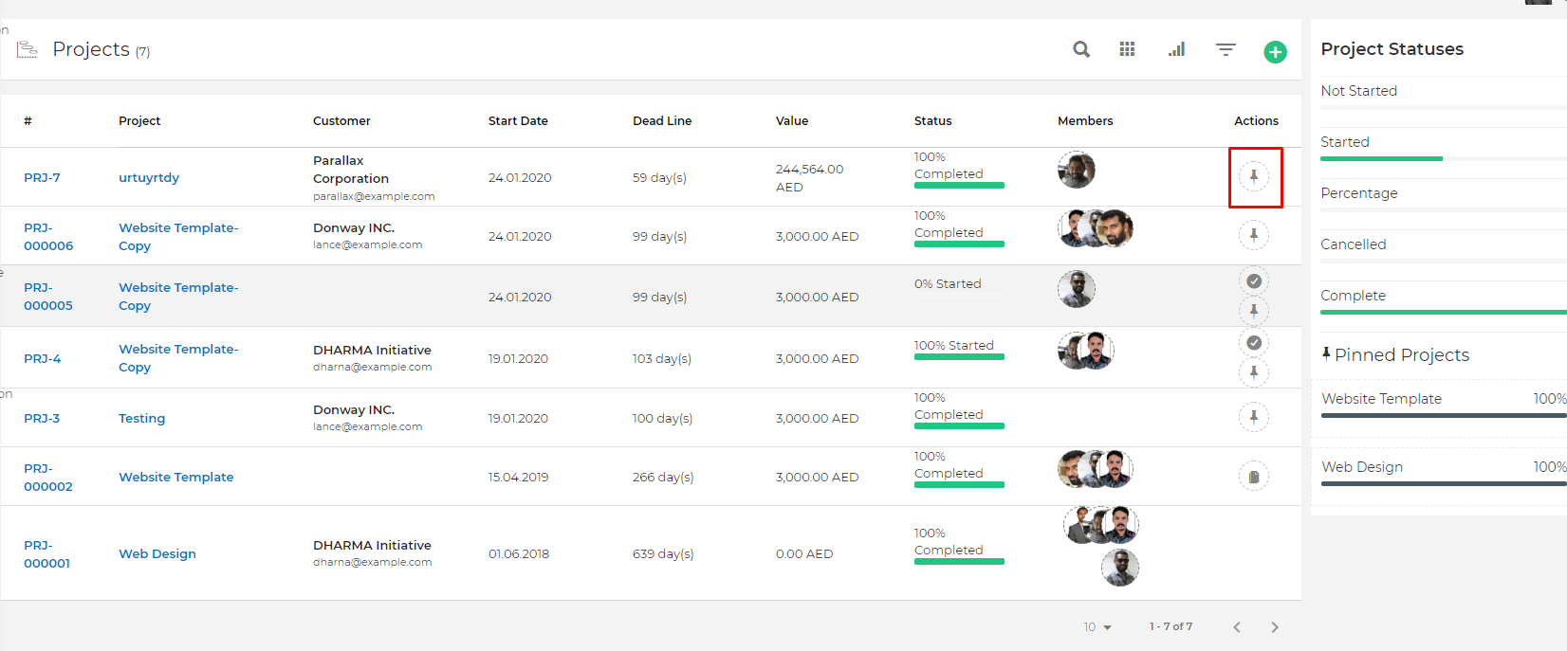

**Filter for status**

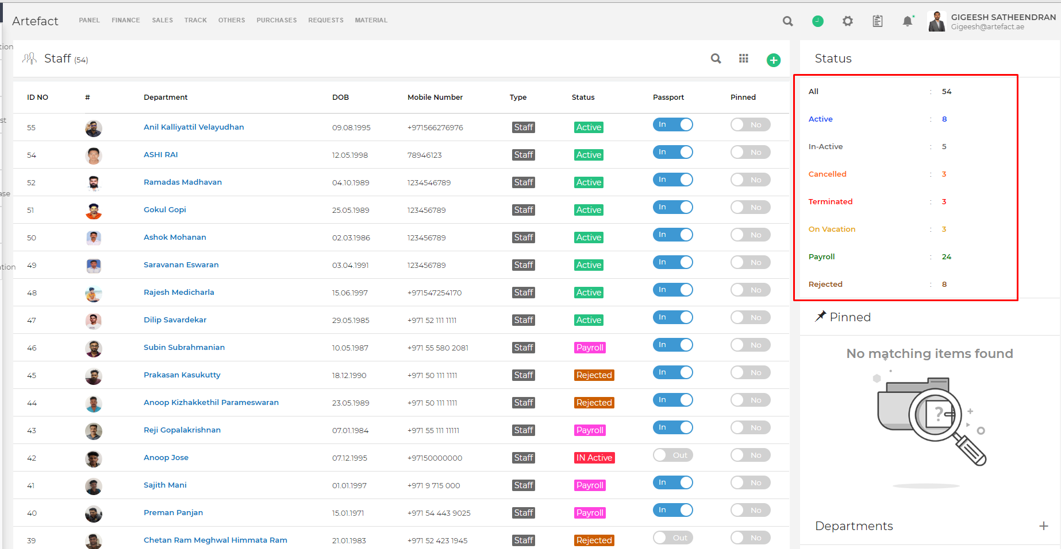

**I need status filter like this to see multiple status**

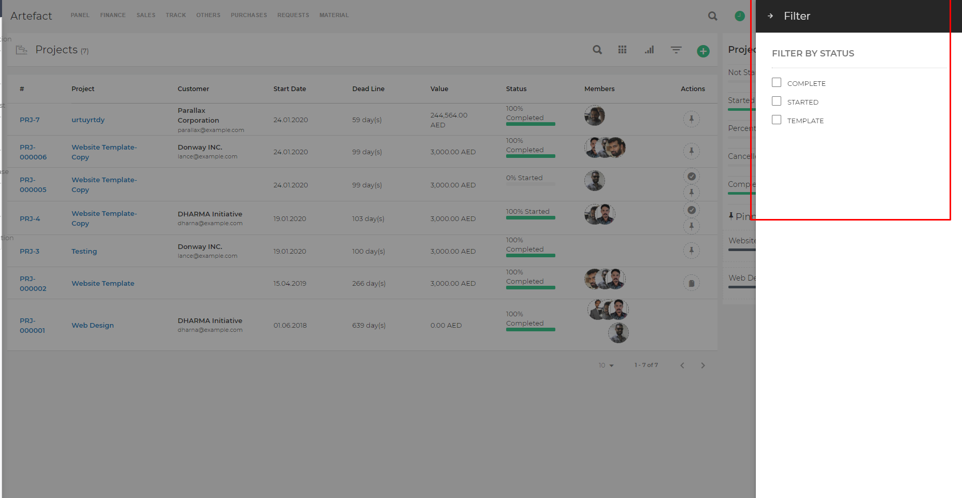

**STAFF Attendance Graph**

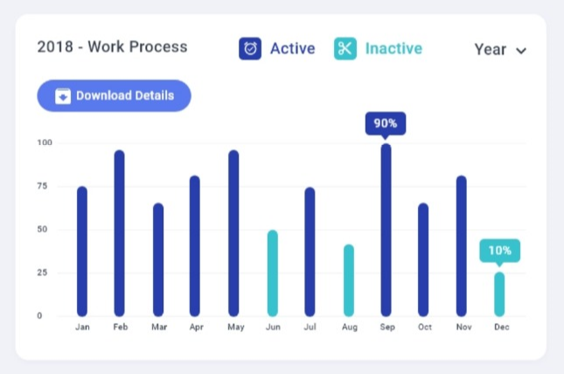

Contacts

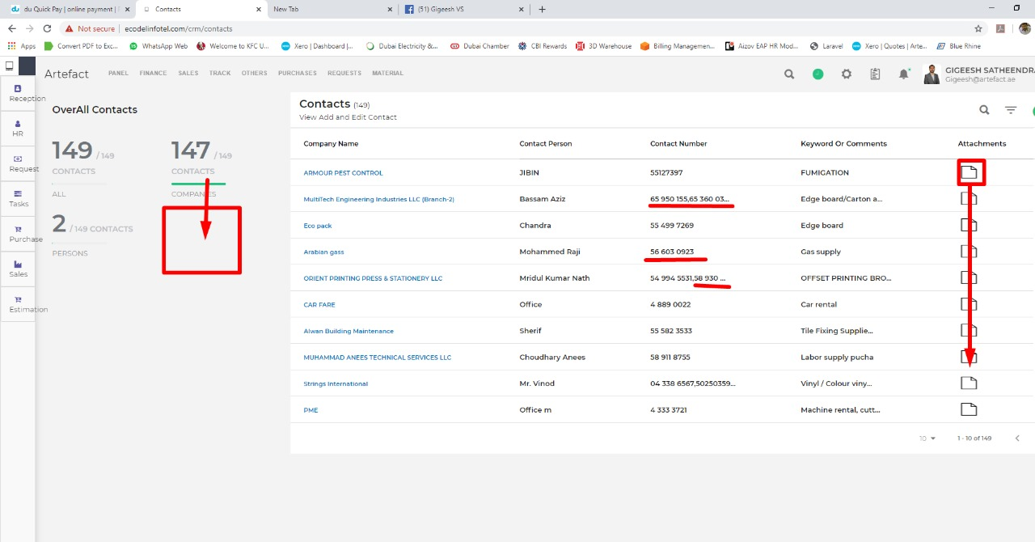

If attachments are there it has to shown attachment icon in list if there is no attachment show as –

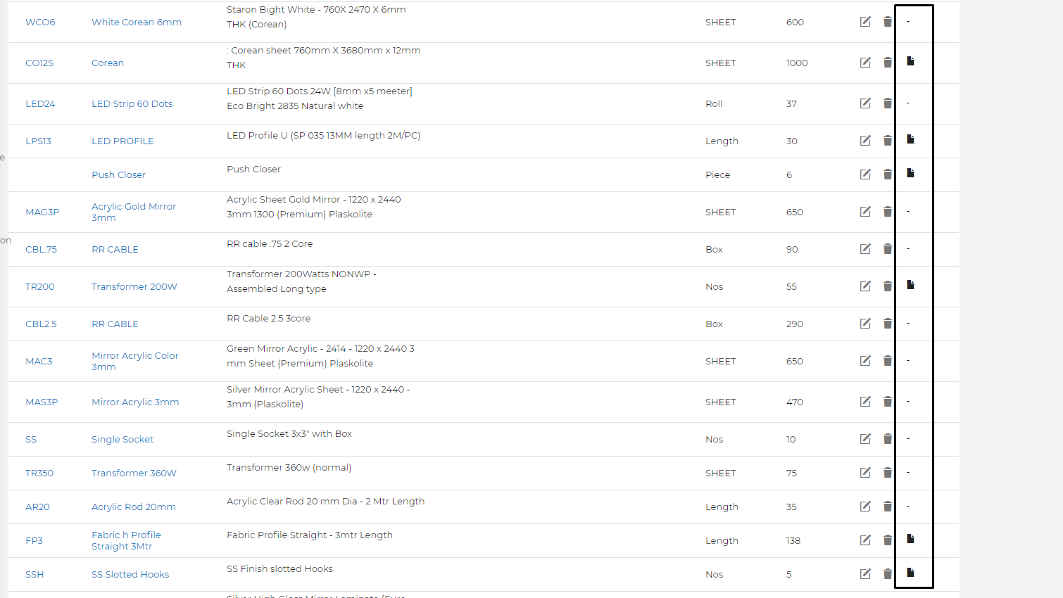

And I need Personal and companies’ side by side I I need filter for that if I click on 147 the only companies contacts will show on list

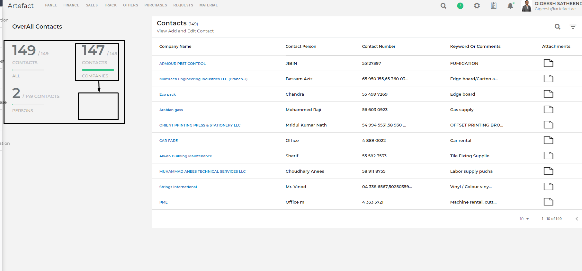

Doc view:

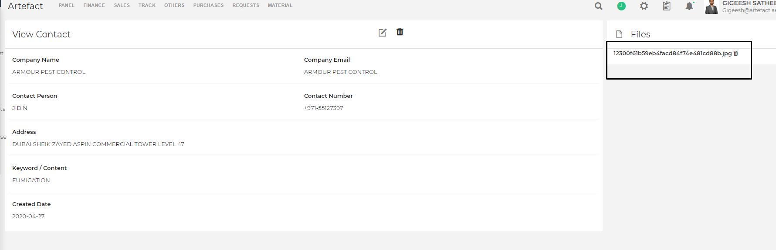

Date format

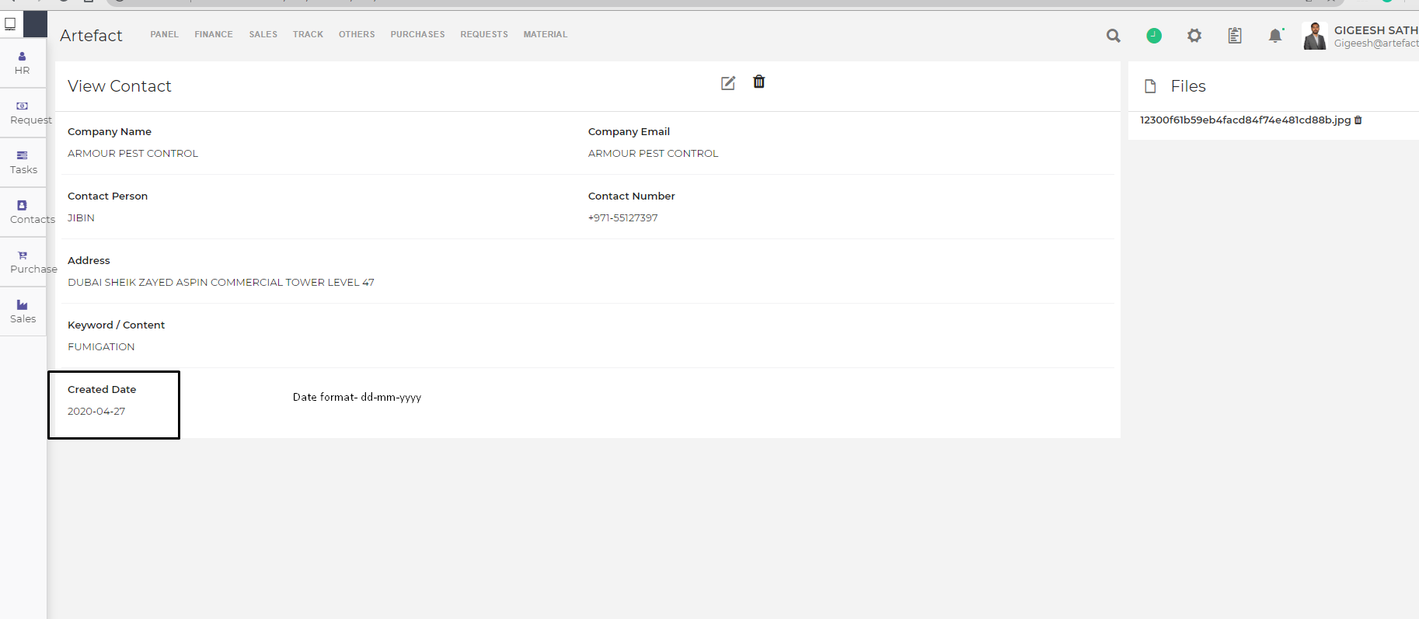

I need view for docs or images..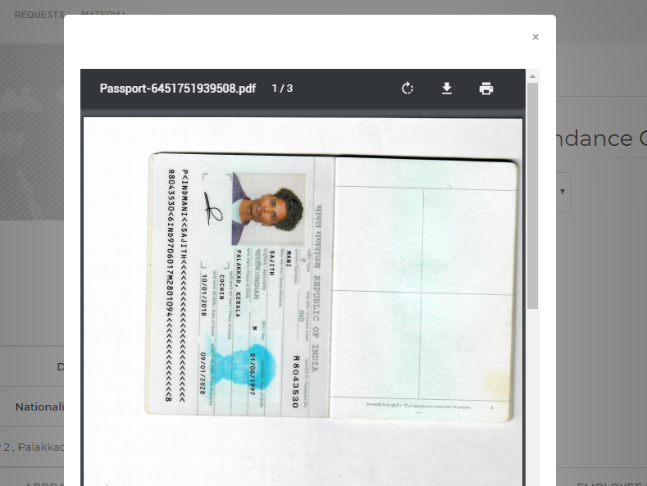

Contacts view in list

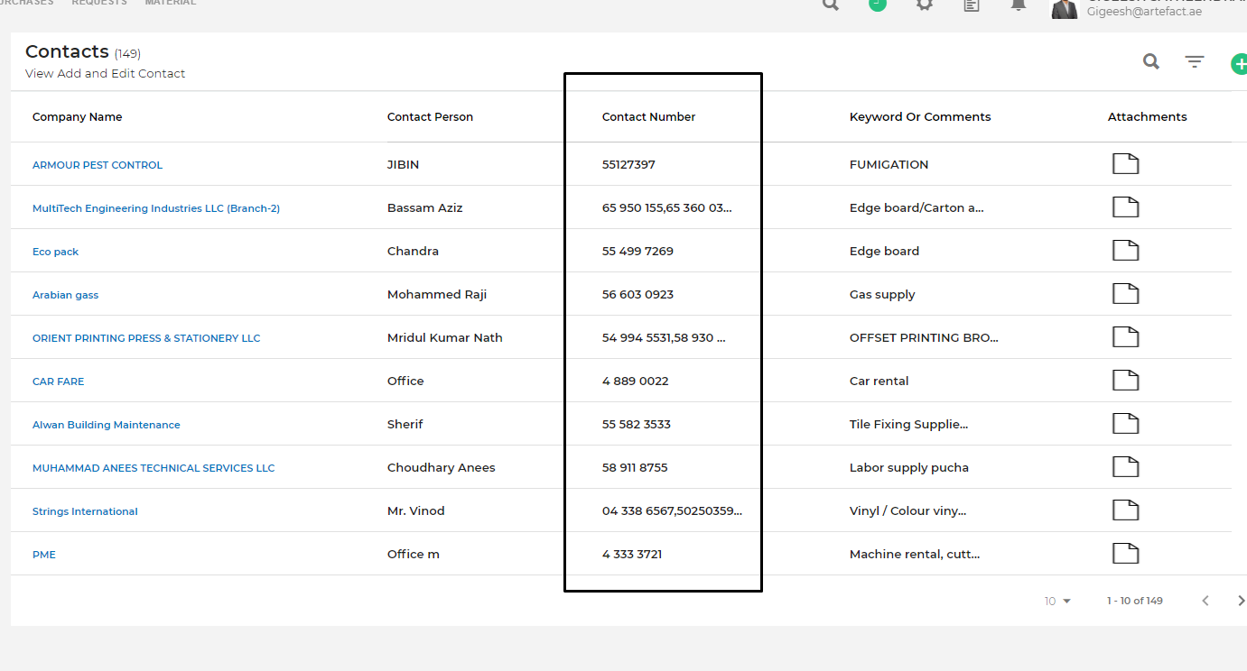

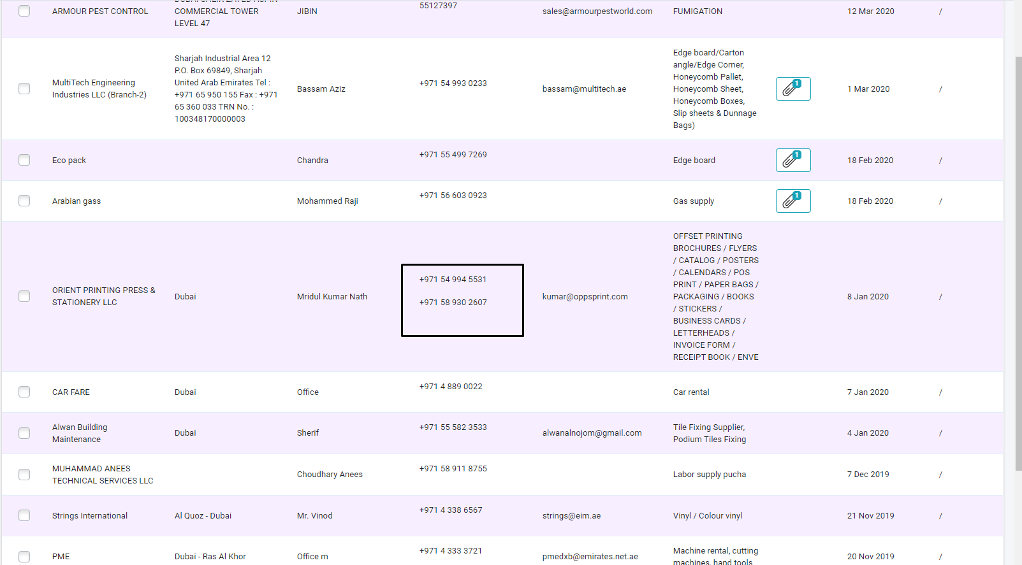

**Requests**

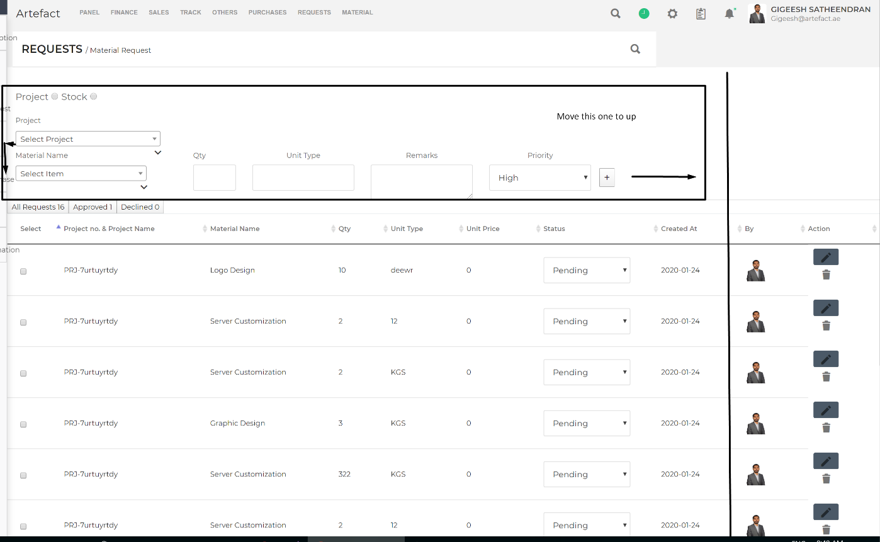



Make them align project and material in one line and project must be written box we need and materail also we need written search box it will connect to material list

And decrease the list width we need space on right side we will put something after

I need this search for material request and I need filter button

Edit and delete button has to be side by side these buttons design same in material

Follow the same view for every request module

Supplier

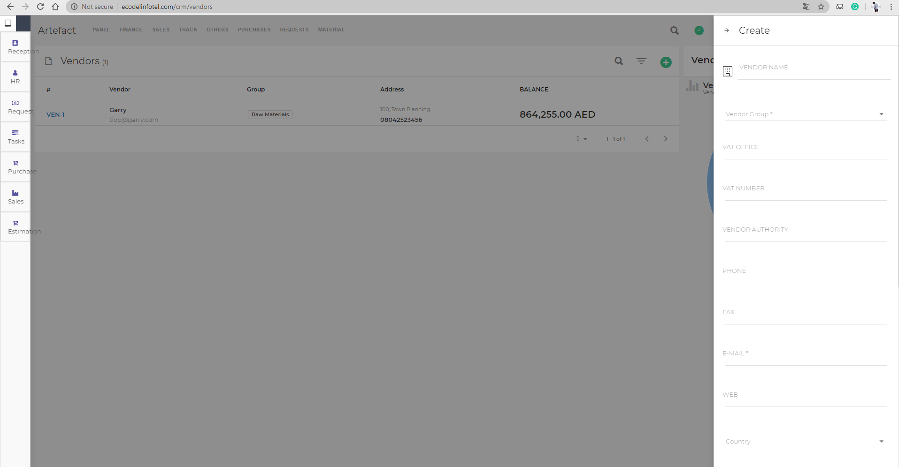

company name

status

company address

contact number office

contact person(accounts)

email address

mobile number

website

country

trade lisence no-expiry date-attachments

credit period

credit limit

terms and conditions

notes

Point of contacts

We have to add these fields to vendor create list and view these fields in view form

Customers

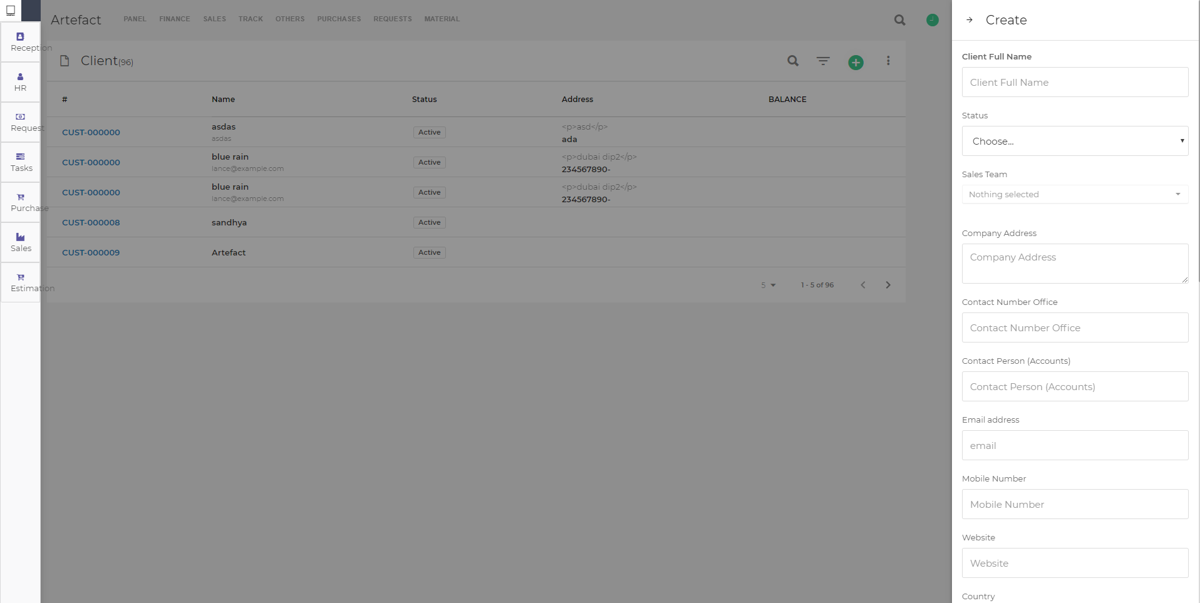

status

sales team

company adress

contact person office

contact person(accounts)

mobile number

Trade details

-lisence number-expiry date-attachments

-vat number-attachments

credit period

credit limit

terms & conditions

notes

we have to add these fields to customer and view these fields in view form